Task 9 – JUnit Testing: Steps
Step 1: Create a new Java Project named Task9.
Step 2: Under the src folder, create a new package named junitDemo.
Step 3: Inside the package, create a class named Calculator.
Step 4: Type the Calculator code and save the file.
Step 5: Select New → JUnit → JUnit Test Case.
Step 6: Enter the JUnit test class name as CalculatorTest and select JUnit 5.
Note: JUnit 5 will be automatically displayed under the next steps/build path option. Click OK and create the CalculatotTest. Type the test code and save it.
Step 7: Right-click CalculatorTest → Run As → JUnit Test.
Step 8: If there is no error: All test cases will pass successfully and the JUnit result will be displayed in green.
- If there is an error: The JUnit result will be displayed in red. Check the Failure Trace to identify the failed test case and the corresponding error. Correct the code and run the JUnit test again.

Calculator.java
public class Calculator {
public int add(int a, int b) {
return a + b;
}
public int divide(int a, int b) {
if (b == 0)
throw new IllegalArgumentException("Division by zero");
return a / b;
}
}

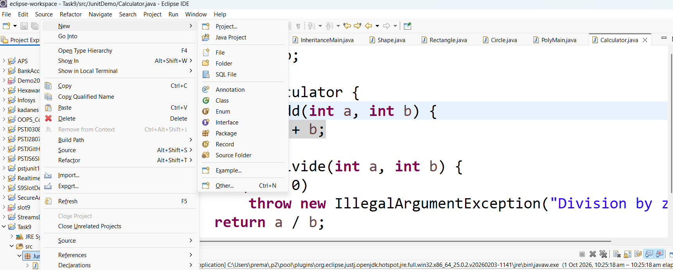
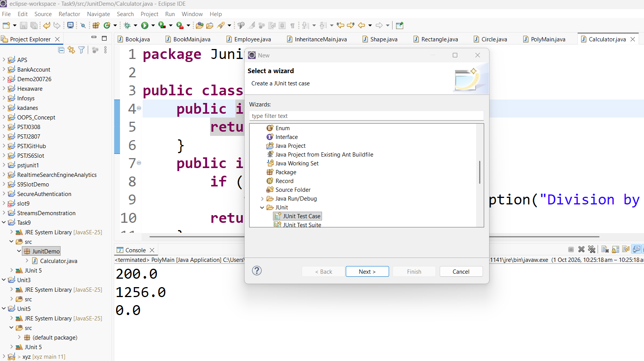
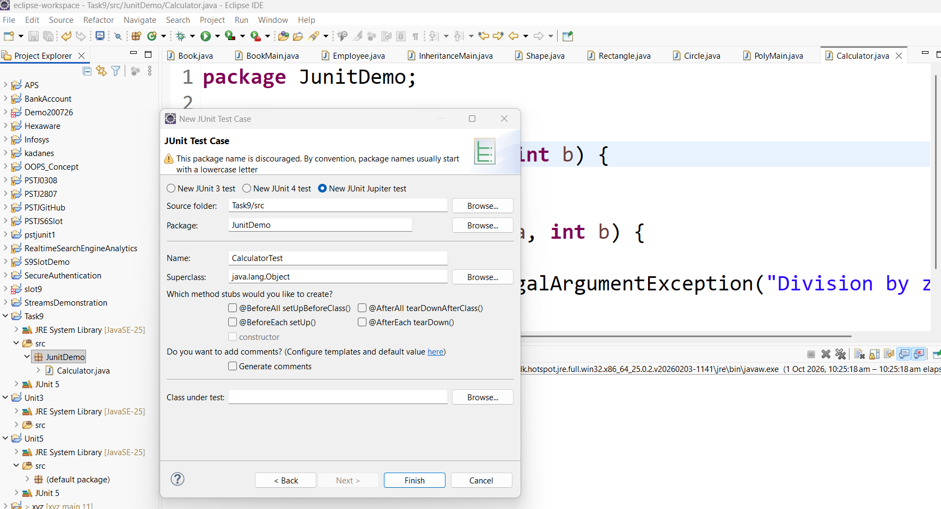

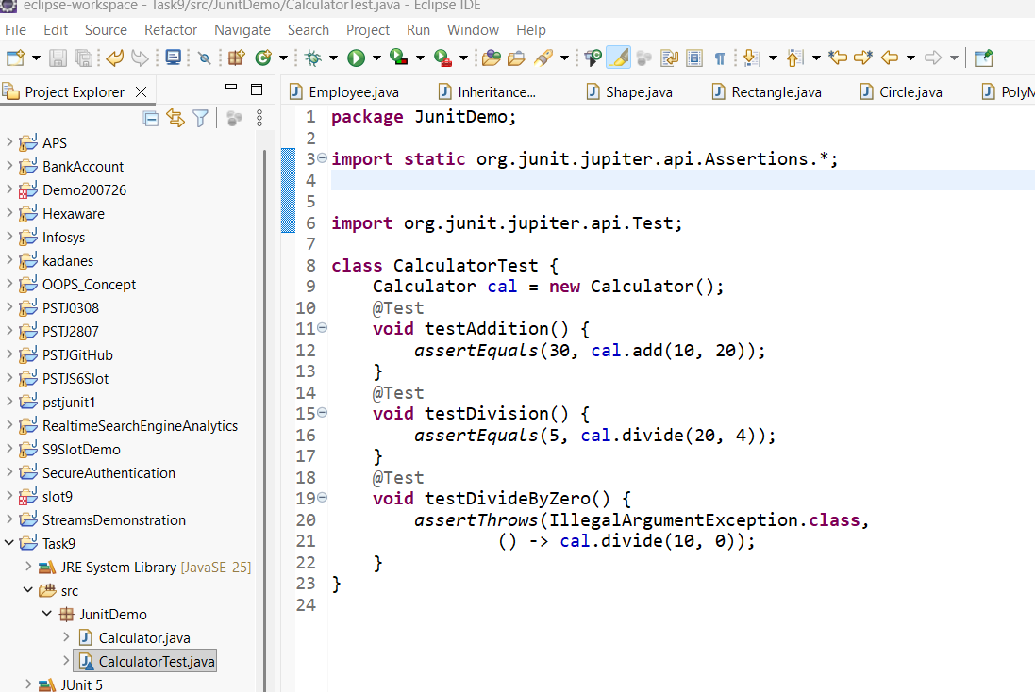

import static org.junit.jupiter.api.Assertions.*;
import org.junit.jupiter.api.Test;
class CalculatorTest {
Calculator cal = new Calculator();
@Test
void testAddition() {
assertEquals(30, cal.add(10, 20));
}
@Test
void testDivision() {
assertEquals(5, cal.divide(20, 4));
}
@Test
void testDivideByZero() {
assertThrows(IllegalArgumentException.class,
() -> cal.divide(10, 0));
}
}

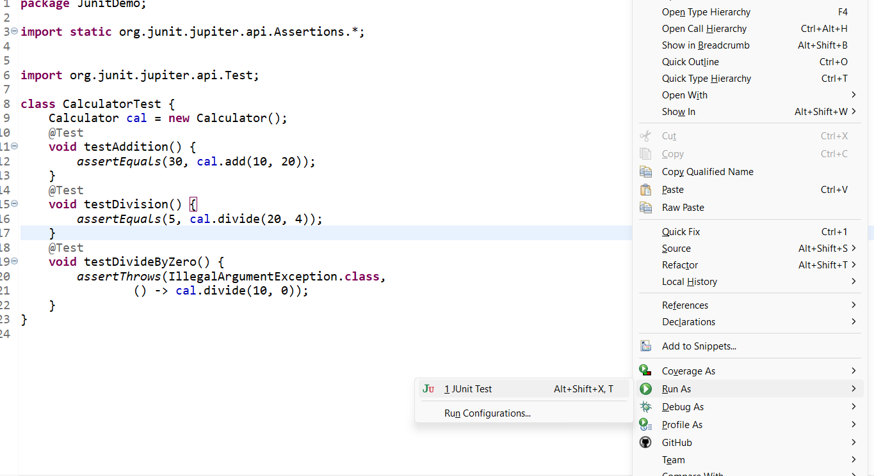

Output:
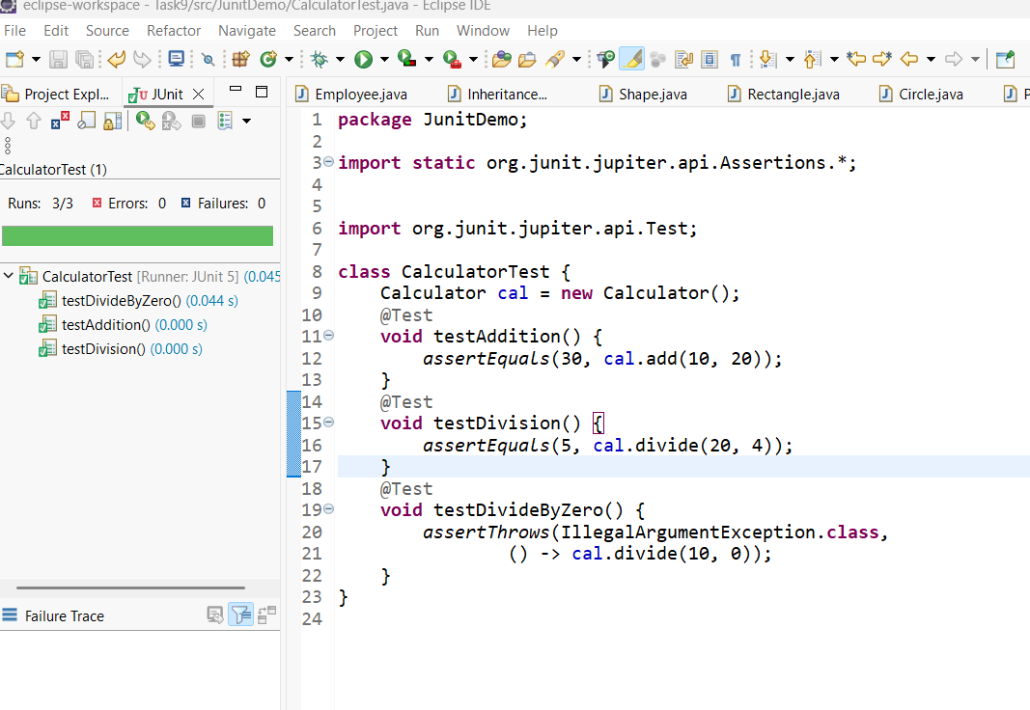
For Wrong Testcase:
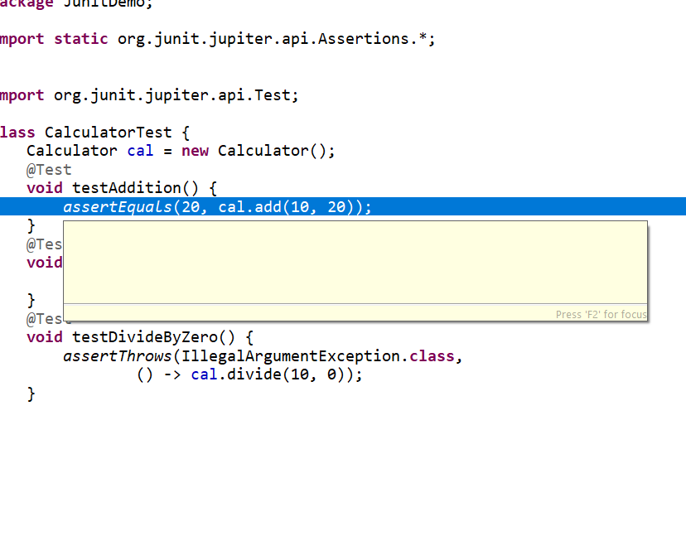Test case fails for wrong Test Input/Output:
